High-Frequency Trading
When Microseconds Are the Edge
A Level 5 module in the Quantitative Finance Curriculum
Covers: market microstructure at the message level · limit order books / matching engines · queue priority · latency / co-location · market-data feeds / binary protocols · order gateways / feed handlers · low-latency programming · lock-free structures · kernel bypass / network optimisation (awareness)

Table of Contents
Table of Contents 1
How to Use This Guide 1
What you need to know before starting 1
Why it matters 1
How this connects to the rest of the curriculum 1
Glossary of recurring terms 1
Part 1 — Market Microstructure at the Message Level 1
1.1 The Limit Order Book and Price-Time Priority 1
1.2 Order Types and the Matching Engine 1
1.3 Queue Position and Queue Priority 1
1.4 Market Data Feeds and Binary Protocols 1
Part 2 — The Latency Stack: Infrastructure as Alpha 1
2.1 Anatomy of Tick-to-Trade Latency 1
2.2 Co-location and the Physics of Distance 1
2.3 Order Gateways, Feed Handlers, and the Software Stack 1
2.4 Low-Latency Programming: Lock-Free Structures and Kernel Bypass 1
Practical Exercise 1
Common Beginner Mistakes 1
Advanced Extensions 1
Professional Applications 1
Where to Go Next 1

How to Use This Guide
This document is a companion to High-Frequency Trading, the fifth-level module in the quantitative finance curriculum. It covers trading at the level of individual exchange messages: how a limit order book is actually built and matched, how a firm measures and fights for microseconds of latency, and the infrastructure — feed handlers, order gateways, kernel bypass, lock-free code — that makes that fight possible.
Unlike earlier modules, this one is only partly about mathematics. The 'model' in HFT is often simple; the edge lives in engineering. Read Part 1 to understand the market mechanics every HFT strategy depends on, then Part 2 to understand why speed itself costs money and how it is bought.

What you need to know before starting
- Market Microstructure (Depth 4+) — order book mechanics, bid-ask spreads, price-time and pro-rata matching, and how liquidity provision and taking work at the level of individual orders. This module assumes that vocabulary is already comfortable, not new.
- Performance Engineering (Level 4) — profiling, cache-aware data structures, and benchmarking code under realistic load. HFT infrastructure work is performance engineering applied to a trading system, not a separate skill.
- Software Engineering Foundations — working proficiency in a systems-level language (C++ or Rust), comfort with concurrency primitives, and the discipline to test and version-control infrastructure code that other people's capital will run on.
Tip: If you have never written multi-threaded C++ or Rust, or profiled code below the millisecond level, treat that as a prerequisite gap to close before attempting the practical exercise — the exercise will expose it immediately, and no amount of market-microstructure knowledge substitutes for it.

Why it matters
High-frequency trading is a genuinely distinct specialisation, not a faster version of ordinary algorithmic or systematic trading. In Level 3's systematic strategies, the edge is a novel economic insight expressed through code that happens to run automatically. In HFT, the insight itself is often public and well understood — queue position matters, stale quotes are exploitable, correlated instruments move together with a lag — and the entire edge comes from being the first market participant to observe and act on a change, measured in microseconds to low milliseconds. That is an infrastructure problem as much as a research problem, and it changes who competes: success depends on capital for co-location and hardware, and on systems engineering skill, at least as much as on a differentiated idea.

How this connects to the rest of the curriculum
- Research — research here is about microstructure signal decay measured in milliseconds — how quickly an order-book imbalance or a cross-venue price discrepancy disappears — rather than the multi-day or multi-week alpha horizons studied in Level 3. The statistical toolkit overlaps, but the sample sizes are enormous and the effects are tiny per event.
- Development — this is the most demanding development specialisation in the curriculum: kernel-level networking, lock-free data structures, and hardware-aware code where a single unexpected memory allocation or cache miss can cost the trade. Standard software engineering practice (readability, abstraction, garbage-collected languages) is frequently in direct tension with latency requirements.
- Trading — HFT is a genuinely distinct trading discipline that most independent learners cannot fully replicate, because it requires co-location and specialised exchange connectivity that are only economically accessible at institutional scale. Understanding it well is still valuable even without deploying it: it explains a large share of the price behaviour that slower strategies must trade around.

Glossary of recurring terms
Limit order book (LOB) — The exchange's live record of all resting buy (bid) and sell (ask) limit orders for an instrument, organised by price level.
Matching engine — The exchange system that receives incoming orders and matches them against the resting book according to a fixed, deterministic priority rule.
Price-time priority — The most common matching rule: orders are filled first by best price, and among orders at the same price, in the order they arrived (first in, first out).
Pro-rata priority — An alternative matching rule, used on some derivatives venues, in which orders at the same price level are filled in proportion to their size rather than strictly by arrival time.
Queue position — An order's place in the first-in-first-out line of resting orders at its price level; earlier arrival means earlier (better) queue position and a higher probability of being filled before the order is cancelled.
Tick size — The minimum price increment an exchange allows between consecutive price levels for an instrument.
Market data feed — The exchange's outbound stream of order book updates and trade prints, typically distributed as a proprietary binary protocol over multicast UDP (e.g. Nasdaq ITCH, CME MDP 3.0).
Order gateway — The exchange-facing system component that accepts outbound orders, applies pre-trade risk checks, and encodes them into the exchange's order-entry protocol (e.g. Nasdaq OUCH, or FIX).
FIX protocol — Financial Information eXchange, a widely used text-based messaging standard for order routing; too slow for the fastest HFT strategies, which instead use exchange-specific binary protocols.
Tick-to-trade latency — The elapsed time from a market-data event arriving at the strategy's network interface to the resulting order leaving the strategy's network interface.
Co-location — Renting rack space inside (or immediately adjacent to) an exchange's own data centre so that the physical cable distance to the matching engine is as short as possible.
Kernel bypass — Techniques (e.g. DPDK, Solarflare OpenOnload) that let an application read and write network packets directly from user space, skipping the operating system's kernel networking stack to remove its latency and jitter.
Lock-free data structure — A concurrent data structure that allows multiple threads to operate on it without ever taking an operating-system lock, using atomic hardware instructions instead, to avoid the unpredictable delays that locks and thread scheduling introduce.
Jitter — Variability in latency from one event to the next; for HFT, a consistently low P99.9 latency is often more valuable than a lower but more variable median latency.

Part 1 — Market Microstructure at the Message Level
Level 4's market microstructure module introduced the limit order book conceptually. This part goes one level deeper: the exact rules a matching engine uses to decide which order fills first, the vocabulary of order types that let participants express more than 'buy' or 'sell', and the message-level plumbing — binary market-data feeds and order-entry protocols — that every HFT system is built on top of.

1.1 The Limit Order Book and Price-Time Priority
A limit order book is simply two sorted lists: bids (buy orders), sorted from highest to lowest price, and asks (sell orders), sorted from lowest to highest price. The highest bid and lowest ask are the best bid and best ask; the gap between them is the bid-ask spread. Figure 1.1 shows a snapshot with eight price levels on each side.
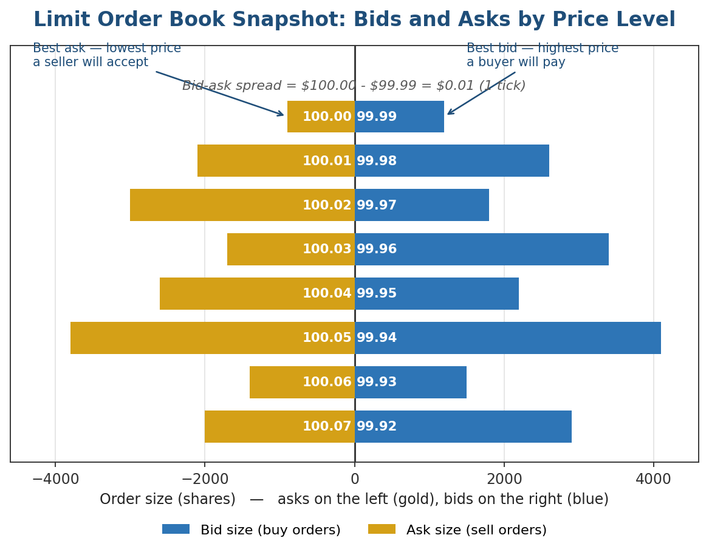
Figure 1.1 — A limit order book snapshot. Each bar is the total resting size at a price level; the best bid and best ask sit closest to the centre, one tick apart.
Under price-time priority, the most common matching rule across major equity and futures exchanges, incoming marketable orders are matched first against the best-priced resting orders, and orders at the same price are filled strictly in the order they arrived:
Priority: better price first, then earlier arrival time at that price
This single rule is the foundation of everything in this module. It means two economically identical orders — same instrument, same price, same size — can have completely different values depending only on when they reached the exchange, which is precisely what turns speed into an edge.
Why this distinction matters: Not every venue uses price-time priority. Many futures markets use pro-rata priority at the best price, in which fill probability scales with order size rather than arrival time. The two rules reward completely different behaviour: price-time rewards being first, pro-rata rewards being large. An HFT strategy tuned for one will misbehave on a venue using the other.

1.2 Order Types and the Matching Engine
Beyond simple buy/sell limit and market orders, exchanges support order types that let a participant express conditions on execution. The table below covers the types most relevant to HFT strategies.
Order type | Behaviour | Typical HFT use
Market order | Executes immediately at the best available price(s); no price limit. | Rarely used directly — gives up control of execution price and queue position.
Limit order | Rests in the book at a specified price until filled or cancelled. | The basic building block of market making; posts liquidity and earns queue priority over time.
Immediate-or-cancel (IOC) | Fills whatever quantity it can immediately; any unfilled remainder is cancelled, not queued. | Used to take liquidity without leaving a resting footprint that could be adversely selected.
Fill-or-kill (FOK) | Must fill its entire quantity immediately or the whole order is cancelled. | Used when a partial fill would leave an unwanted, unhedged residual position.
Pegged order | Automatically re-prices to track a reference (e.g. the best bid) as the market moves. | Maintains a competitive queue position without manual re-quoting on every tick.
Hidden / iceberg order | Displays only part of its full size; the rest replenishes as the visible slice fills. | Lets a large resting order avoid signalling its full size to other participants.
A simplified matching engine, at its core, is a loop that processes one inbound message at a time and applies price-time priority deterministically:
function on_new_order(order):
book = get_book(order.symbol)
while order.quantity > 0 and book.crosses(order):
resting = book.best_opposing_order()
fill_qty = min(order.quantity, resting.quantity)
emit_trade(order, resting, fill_qty, resting.price)
order.quantity -= fill_qty
resting.quantity -= fill_qty
if resting.quantity == 0:
book.remove(resting) # next order in queue is now first
if order.quantity > 0 and order.type == LIMIT:
book.insert_at_back_of_queue(order) # joins the tail at its price level
Common mistake: Assuming a limit order 'improves' its queue position over time just by resting. It does not — an order keeps its original queue position only if it is never modified. Cancelling and re-submitting an order at the same price (even to fix an unrelated field) sends it to the back of the queue, which is why production systems track queue position carefully before deciding to modify an order.

1.3 Queue Position and Queue Priority
Because price-time priority rewards early arrival, a resting order's exact position in the queue at its price level determines its probability of filling before being cancelled or before the price moves away. Figure 1.2 shows a queue of four resting orders at the best bid, with a new order joining at the back.
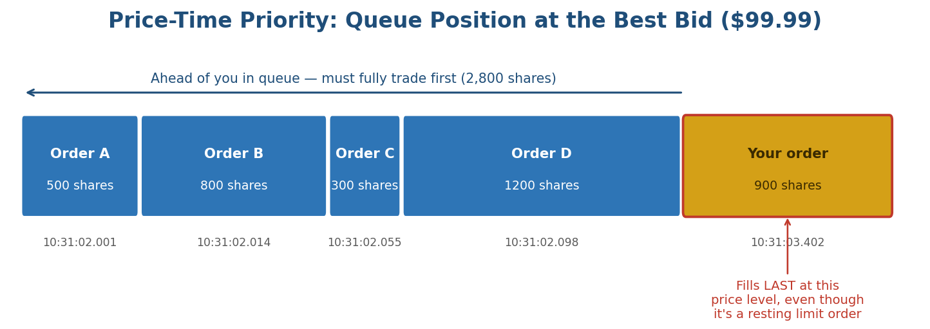
Figure 1.2 — Orders A–D arrived earlier and must trade in full before a new order at the same price can fill — even though all five orders sit at an identical price.
HFT market-making systems track queue position explicitly rather than treating the book as a single visible number, because the publicly displayed size at a price level does not reveal how many shares are ahead of a specific order. A common estimate tracks the number of shares that have traded or been cancelled ahead of the order's known arrival sequence number:
estimated_shares_ahead(t) = shares_ahead(t0) − volume_traded_at_price(t0, t) − cancels_ahead(t0, t)
This estimate degrades over time (cancellations ahead of an order are not directly observable, only inferable), which is itself a research problem — accurately modelling queue position is one of the more valuable, less discussed pieces of HFT market-making infrastructure.

1.4 Market Data Feeds and Binary Protocols
Exchanges publish order book updates as a continuous stream of small, fixed-format binary messages, distributed over multicast UDP so that many recipients can subscribe to the same feed simultaneously without the exchange sending a separate copy to each one. Nasdaq's ITCH protocol and CME's MDP 3.0 are two well-known examples. Each message reports one atomic change: a new order added, an order reduced or cancelled, or a trade executed.
// simplified fixed-width binary message, similar in spirit to Nasdaq ITCH
struct AddOrderMessage {
uint8_t msg_type; // 'A' = add order
uint64_t timestamp_ns; // nanoseconds since midnight, exchange clock
uint64_t order_id;
char side; // 'B' or 'S'
uint32_t shares;
char symbol[8];
uint32_t price; // fixed-point, e.g. price * 10000
}; // 33 bytes, no padding, no delimiters — parsed by fixed offsets, not by scanning
A feed handler is the component that subscribes to this multicast stream, tracks the exchange's message sequence numbers to detect and request retransmission of any gaps, and reconstructs a normalised in-memory copy of the order book for the strategy engine to read. Figure 1.3 places the feed handler in the full round trip from market data to a strategy's own order.
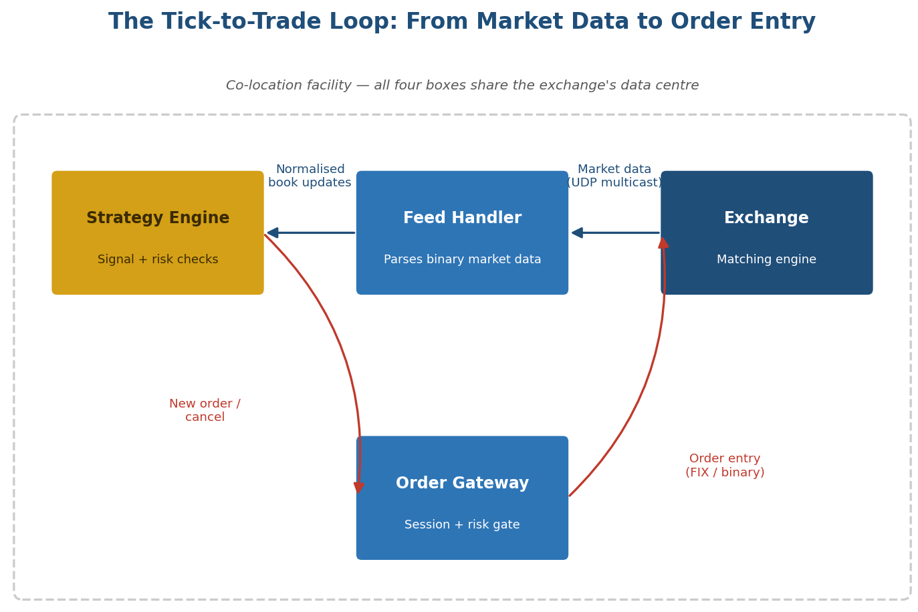
Figure 1.3 — The tick-to-trade loop. Every hop in this diagram is a source of latency, and every box, ideally, sits physically inside the exchange's data centre.
Tip: A subtle point worth internalising early: the exchange's own direct binary feed is materially faster than the consolidated public feed (the 'SIP' in US equities) that aggregates data across all venues. Strategies that depend on being first must subscribe directly to each venue's own feed, at a real infrastructure and cost premium, rather than relying on any single aggregated source.

Part 2 — The Latency Stack: Infrastructure as Alpha
Part 1 covered the market mechanics that make speed valuable. This part covers where that speed actually comes from: the full latency budget of a trade, the physical reality of distance and the speed of light, the software stack between market data and an order, and the specific low-level programming techniques — lock-free structures and kernel bypass — used to remove every avoidable microsecond.

2.1 Anatomy of Tick-to-Trade Latency
Tick-to-trade latency is the sum of every processing and transmission delay between a market-data event landing on a strategy's network card and the resulting order leaving it. Figure 2.1 breaks a representative, already highly-optimised, co-located budget into its component stages.
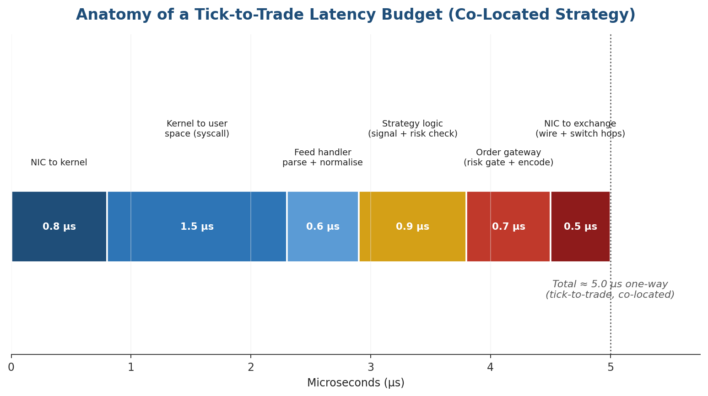
Figure 2.1 — Each stage looks small in isolation, but they compound: a firm that is 20% slower at every single stage is not competitive, even though no individual stage looks disqualifying on its own.
A useful way to think about the budget:
tick-to-trade = t_NIC→kernel + t_kernel→user + t_parse + t_strategy + t_gateway + t_wire→exchange
Two numbers matter more than the mean: the median (typical performance) and the tail — usually reported as P99 or P99.9 latency (the worst case that still happens routinely). A system with a fast median but a fat tail will lose the race precisely on the volatile, fast-moving moments when winning it is worth the most, which is why HFT engineering teams optimise for consistency at least as hard as for the average case.
// hardware timestamp counter, x86 — far cheaper than a syscall-based clock read
static inline uint64_t rdtsc() {
unsigned lo, hi;
__asm__ __volatile__ ("rdtsc" : "=a"(lo), "=d"(hi));
return ((uint64_t)hi << 32) | lo;
}
// timestamp at ingress and at egress of every stage; store to a lock-free ring
// buffer for offline analysis rather than logging synchronously on the hot path
Common mistake: Measuring latency by calling a standard library clock function (e.g. a syscall-based wall-clock read) inside the hot path. The measurement instrument itself can cost more than the thing it is measuring. Production systems timestamp with a hardware counter and analyse the results offline, never on the critical path.

2.2 Co-location and the Physics of Distance
Signals cannot travel faster than the speed of light, and in optical fibre they travel at roughly two-thirds of the speed of light in a vacuum, around 200,000 km/second. That single physical fact is the entire economic justification for co-location:
round-trip time ≈ 2 × distance / (2/3 × c)
Over a genuinely short distance — a few metres of cable between adjacent racks — this is a fixed cost of nanoseconds. Over hundreds of kilometres, it becomes a fixed cost of milliseconds that no amount of software optimisation can remove. Figure 2.2 puts real-world scenarios on the same (logarithmic) scale.
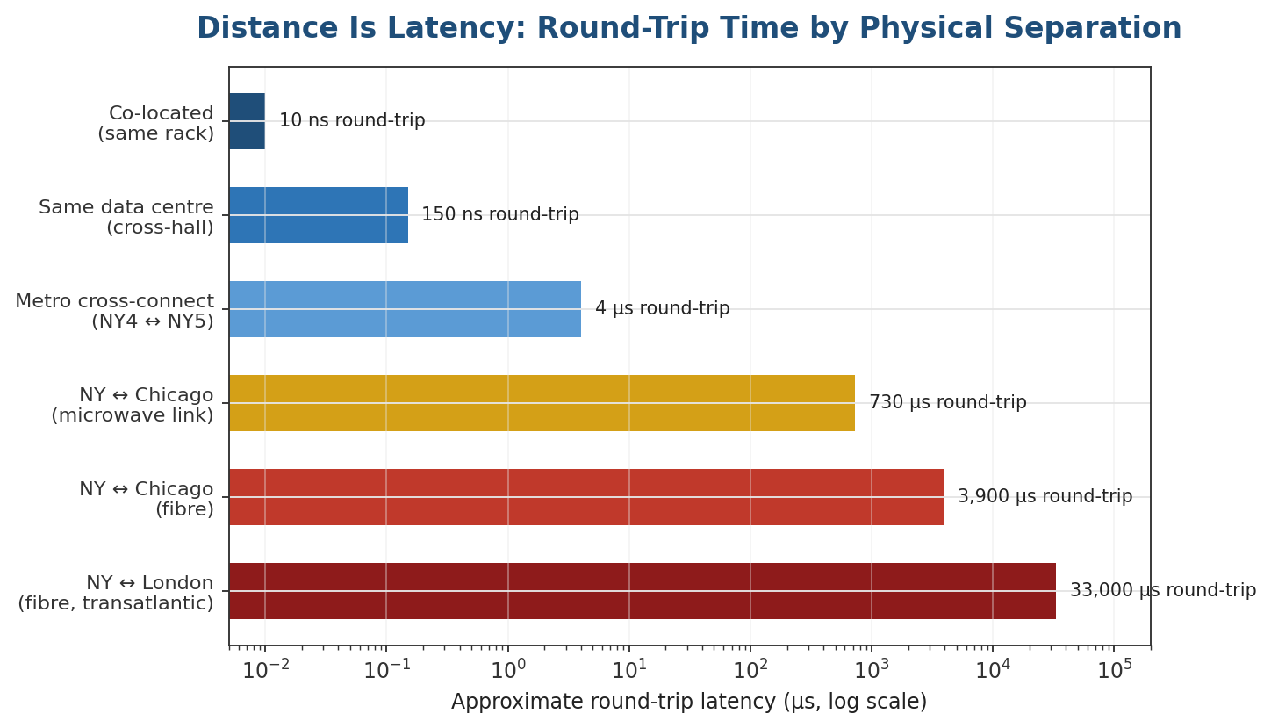
Figure 2.2 — Distance dominates every other latency source once two venues are in different cities. Microwave links beat fibre over long distances because line-of-sight air is a faster medium than glass.
This is also why microwave and millimetre-wave links, not fibre, carry the most latency-sensitive inter-city routes (for example, between the primary US equity/options data centres in New Jersey and the futures data centre near Chicago): line-of-sight radio through air travels closer to the vacuum speed of light than light does inside glass fibre, and the relatively small latency saved translates directly into fill-rate advantage.
Why this distinction matters: Co-location buys a firm a fixed, physical latency advantage that is available to any competitor willing to pay for the same rack space — it does not, by itself, constitute a durable edge. The actual edge has to come from being consistently faster than other equally co-located, equally well-connected competitors, which pushes the competition down into software and hardware engineering rather than geography.

2.3 Order Gateways, Feed Handlers, and the Software Stack
The order gateway is the last piece of a firm's own infrastructure before an order reaches the exchange, and it carries a genuine tension: it must apply pre-trade risk checks (fat-finger limits, self-trade prevention, order-rate throttles) that regulation requires — in the US, SEC Rule 15c3-5, the 'market access rule' — while adding as little latency as possible to every single order.
Risk check | What it catches | Latency cost if naive
Fat-finger / notional limit | An order with a wildly wrong price or size (e.g. a misplaced decimal). | A single comparison against a pre-computed limit; negligible if done right.
Self-trade prevention | The firm's own resting order matching against its own new order. | Requires a fast lookup against the firm's own live order set.
Order-rate throttle | A runaway strategy sending an unbounded burst of orders. | A counter with a rolling time window; cheap, but must not lock.
Kill switch | Manual or automatic full stop of all order flow from a strategy. | Must be checked on every order, so it has to be a single atomic flag read.
The engineering answer is to make every check a small number of branch-predictable comparisons against values that are pre-computed and cached in the hot path, rather than anything that touches a database, allocates memory, or takes a lock — the same discipline that shows up throughout Section 2.4.

2.4 Low-Latency Programming: Lock-Free Structures and Kernel Bypass
Two techniques do most of the work of removing avoidable latency and jitter from a trading system's software stack.

Lock-free data structures
A conventional mutex-protected queue can block a thread for an unpredictable length of time whenever another thread holds the lock, and that unpredictability (jitter) is often worse for a trading system than a slightly higher but consistent latency. Lock-free structures instead use atomic CPU instructions — typically compare-and-swap (CAS) — so that multiple threads can safely read and write shared data without ever blocking each other.
// single-producer, single-consumer lock-free ring buffer (simplified)
template <typename T, size_t N>
class SpscRingBuffer {
std::array<T, N> buf;
std::atomic<size_t> head{0}; // written only by producer
std::atomic<size_t> tail{0}; // written only by consumer
public:
bool push(const T& item) {
size_t h = head.load(std::memory_order_relaxed);
size_t next = (h + 1) % N;
if (next == tail.load(std::memory_order_acquire)) return false; // full
buf[h] = item;
head.store(next, std::memory_order_release);
return true;
}
};

Kernel bypass and network optimisation (awareness level)
Reading a network packet the standard way means the kernel copies data from the network card, through its own TCP/IP stack, into a buffer the application then has to read via a system call — several context switches and memory copies, each adding both latency and jitter. Kernel-bypass frameworks (Solarflare/Xilinx OpenOnload, Intel/6WIND DPDK) let an application talk to the network card directly from user space, skipping the kernel networking stack entirely.
Approach | Typical one-way latency | Trade-off
Standard kernel sockets | 10–50 µs, high jitter | Simple, portable, well-supported by every tool and language.
Kernel bypass (user-space NIC) | 1–5 µs, low jitter | Requires specialised NIC drivers and a dedicated CPU core to poll for packets.
FPGA-based network processing | Tens to low hundreds of nanoseconds | Custom hardware design; very high fixed cost and specialised skill to build and change.
Other recurring techniques worth being aware of, even before mastering them: pinning latency-critical threads to dedicated CPU cores and disabling frequency scaling on those cores; avoiding heap allocation entirely on the hot path (pre-allocating all memory at startup); aligning frequently-accessed data to CPU cache-line boundaries to avoid false sharing between cores; and writing branch-predictable code, since a mispredicted branch can cost more cycles than several arithmetic operations.
Why this distinction matters: None of this is exotic for its own sake — every technique above exists to make one number (latency) both lower and, just as importantly, more consistent. A system that is occasionally very fast but sometimes slow is usually worse for HFT than one that is reliably just OK, because the tail is exactly when competition is fiercest.

Practical Exercise
Build a simplified limit-order-book matching engine in a low-level language (C++ or Rust), then measure its order-processing latency under load and identify the bottleneck.
- Implement a single-instrument order book supporting add, cancel, and market/limit orders, matched under strict price-time priority (Section 1.2's pseudocode is a reasonable starting point).
- Generate a synthetic load of at least 1,000,000 messages (a mix of adds, cancels, and marketable orders) and feed them through the engine sequentially.
- Timestamp every message with a hardware counter (Section 2.1) on entry and exit, and record the full latency distribution — not just the mean.
- Report the median, P99, and P99.9 latency, and plot the distribution; identify which stage (parsing, book lookup, matching, memory allocation) dominates the tail rather than the average.
- Remove one source of overhead you identified — for example, replace a mutex-protected book with a single-threaded design, or eliminate a per-message heap allocation — and re-measure to quantify the improvement.
// skeleton to extend
struct Order { uint64_t id; bool is_bid; uint32_t price; uint32_t qty; uint64_t ts_ns; };
class OrderBook {
std::map<uint32_t, std::deque<Order>, std::greater<>> bids; // price -> FIFO queue
std::map<uint32_t, std::deque<Order>> asks;
public:
void add(Order o); // matches immediately if it crosses, else queues
void cancel(uint64_t id);
// TODO: measure ns per call under load; a std::map is NOT the fast answer —
// that's the point of the exercise
};
Common mistake: Reaching for the 'obviously correct' data structure (like the std::map skeleton above) and stopping there. It is a fine starting point, but a red-black tree with per-node heap allocation is a textbook example of the kind of unpredictable latency this module warns against — finding that out by measuring it, on your own machine, is the actual point of the exercise.

Common Beginner Mistakes
Mistake 1 — Conflating fast systematic trading with true HFT: Treating any strategy that trades frequently — rebalancing every few seconds or minutes — as 'HFT'. True HFT operates on microsecond timescales and requires categorically different infrastructure: co-location, kernel bypass, and hardware timestamping, none of which a seconds-to-minutes strategy needs or benefits from.
Mistake 2 — Underestimating how much of the edge is infrastructure: Assuming HFT profitability comes primarily from a clever signal. In practice a large share of the edge comes from being physically closer to the exchange and technically faster than competitors running very similar, often publicly-understood, strategies — signal sophistication matters far less here than in Level 3's systematic strategies.
Mistake 3 — Measuring latency on the hot path itself: Instrumenting a trading system with syscall-based timers or synchronous logging inside the critical path, which distorts the very measurement it is trying to take. Use hardware timestamp counters and write results to a lock-free buffer for offline analysis instead (Section 2.1).

Advanced Extensions
Two directions extend beyond what most self-study can reach without institutional resources. FPGA and hardware acceleration moves order-book processing and even simple trading logic directly onto reconfigurable hardware, cutting latency from microseconds to tens of nanoseconds at the cost of a much longer and more specialised development cycle (hardware description languages like Verilog or VHDL, not C++ or Rust). Exchange-specific protocol optimisation — hand-tuning a feed handler or order gateway to the exact quirks of a single venue's binary protocol and matching-engine behaviour — can recover the last few hundred nanoseconds of advantage, but requires a level of access to exchange documentation, test environments, and connectivity that is generally only available to firms with institutional relationships with the venue itself.

Professional Applications
- Proprietary HFT firms — trading firm capital directly, with strategies ranging from passive market making to latency arbitrage across correlated instruments and venues; profitability depends on infrastructure investment as much as strategy design.
- Exchange-adjacent market making — formal or informal designated market-maker programmes that provide continuous liquidity in exchange for reduced fees or rebates, requiring the same low-latency infrastructure to manage quoting risk safely.
- Latency arbitrage and cross-venue trading — exploiting the brief windows in which the same or economically linked instruments are priced differently across venues, a strategy category that exists only because of the latency asymmetries this module describes.

Where to Go Next
This module completes the infrastructure-facing side of the curriculum: how markets actually process individual messages, and how firms compete on the speed of getting a message from observation to action. Combined with Level 3's systematic strategies and Level 4's microstructure and performance-engineering modules, it gives a complete picture of where trading edges come from — an idea, or speed, or usually some mixture of both.

Suggested paths depending on your focus
- Heading into research: focus on microstructure signal decay — measuring how quickly order-book-based signals lose predictive power, which is the research question that actually matters at HFT timescales, as distinct from the multi-day alpha research of Level 3.
- Heading into infrastructure/development: go deep on Section 2.4 — build and benchmark your own lock-free structures, then experiment with a kernel-bypass networking library on a spare machine to feel the difference directly rather than only reading about it.
- Heading into trading: focus on Sections 1.1–1.3 and the queue-position mathematics — understanding exactly how and why speed translates into fills is what lets a slower strategy trade intelligently around HFT activity rather than being adversely selected by it.

